# CANDIDATE’S DECLARATION

I, hereby declare that the work presented in this project entitled “**Criminal Face Detection**” in the partial fulfillment of the requirements for the award of the Degree of Bachelor of Technology in Computer Science & Engineering at Jaipur Engineering College and Research Centre, Jaipur is an authentic work of my own.

I have not submitted the matter embodied in this project work anywhere for the award of degree of Bachelor of Technology in Computer Science & Engineering.

**Student Name:** Archit Sharma **Univ. Roll No. :** 20EJCCS046 **Date :** 29/04/2024

**Place:** Jaipur

# BONAFIDE CERTIFICATE

This is to certify that the project entitled **" Criminal Face Detection "** is the bonafide work carried out by student of B.Tech. in Computer Science & Engineering at Jaipur Engineering College and Research Centre, during the year 2023-24 in partial fulfillment of the requirements for the award of the Degree of Bachelor of Technology in Computer Science & Engineering and the project has not formed the basis for the award previously of any degree, diploma, fellowship or any other similar title.

**Name of Guide:** Mr. Pushpraj Tripathi

**Designation:** Assistant professor **Place:** Jaipur

**Date:** 04/04/2024

# VISION OF CSE DEPARTMENT

To become renowned Centre of excellence in computer science and engineering and make competent engineers and professionals with high ethical values prepared for lifelong learning.

# MISSION OF CSE DEPARTMENT

1. To impart outcome based education for emerging technologies in the field of computer science and engineering.
2. To provide opportunities for interaction between academia and industry.
3. To provide platform for lifelong learning by accepting the change in technologies.
4. To develop aptitude of fulfilling social responsibilities.

## PROGRAM OUTCOMES (POs)

1. **Engineering knowledge:** Apply the knowledge of mathematics, science, engineering fundamentals, and an engineering specialization to the solution of complex engineering problems.
2. **Problem analysis**: Identify, formulate, research literature, and analyze complex engineering problems reaching substantiated conclusions using first principles of mathematics, natural sciences, and engineering sciences.
3. **Design/development of solutions**: Design solutions for complex engineering problems and design system components or processes that meet the specified needs with appropriate consideration for the public health and safety, and the cultural, societal, and environmental considerations.
4. **Conduct investigations of complex problems**: Use research-based knowledge and research methods including design of experiments, analysis and interpretation of data, and synthesis of the information to provide valid conclusions.
5. **Modern tool usage**: Create, select, and apply appropriate techniques, resources, and modern engineering and IT tools including prediction and modeling to complex engineering activities with an understanding of the limitations.
6. **The engineer and society**: Apply reasoning informed by the contextual knowledge to assess societal, health, safety, legal and cultural issues and the consequent responsibilities relevant to the professional engineering practice.
7. **Environment and sustainability**: Understand the impact of the professional engineering solutions in societal and environmental contexts, and demonstrate the knowledge of, and need for sustainable development.
8. **Ethics**: Apply ethical principles and commit to professional ethics and responsibilities and norms of the engineering practice.
9. **Individual and team work**: Function effectively as an individual, and as a member or leader in diverse teams, and in multidisciplinary settings.
10. **Communication**: Communicate effectively on complex engineering activities with the engineering community and with society at large, such as, being able to comprehend and write effective reports and design documentation, make effective presentations, and give and receive clear instructions.
11. **Project management and finance**: Demonstrate knowledge and understanding of the engineering and management principles and apply these to one’s own work, as a member and leader in a team, to manage projects and in multidisciplinary environments.
12. **Life-long learning**: Recognize the need for, and have the preparation and ability to engage in independent and life-long learning in the broadest context of technological change.

## PROGRAM EDUCATIONAL OBJECTIVES (PEOs)

The PEOs of the B.Tech. (CSE) program are:

**PEO1**: To provide students with the fundamentals of Engineering Sciences with more emphasis in computer science and engineering by way of analyzing and exploiting engineering challenges.

**PEO2:** To train students with good scientific and engineering knowledge so as to comprehend, analyze, design, and create novel products and solutions for the real-life problems.

**PEO3**: To inculcate professional and ethical attitude, effective communication skills, teamwork skills, multidisciplinary approach, entrepreneurial thinking and an ability to relate engineering issues with social issues.

**PEO4:** To provide students with an academic environment aware of excellence, leadership, written ethical codes and guidelines, and the self-motivated life-long learning needed for a successful professional career.

**PEO5**: To prepare students to excel in Industry and Higher education by educating Students along with High moral values and Knowledge.

## PROGRAM SPECIFIC OUTCOMES (PSOs)

**PSO1:** Ability to interpret and analyze network specific and cyber security issues, automation in real word environment.

**PSO2:** Ability to Design and Develop Mobile and Web-based applications under realistic constraints.

## COURSE OUTCOMES (COs)

On completion of project Graduates will be able to-

* CO1: Gather, organize, summarize and interpret technical literature with the purpose of formulating a project proposal.
* CO2: Design/Develop the solution using latest technologies and communicate via modern tools.
* CO3 Understand and develop the professional, social ethics, and team management principles.

**MAPPING: CO’s & PO’s**

|  |  |  |  |  |  |  |  |  |  |  |  |  |  |  |  |
| --- | --- | --- | --- | --- | --- | --- | --- | --- | --- | --- | --- | --- | --- | --- | --- |
| **Subject** | **Code** | **L**  **/ T**  **/ P** | **CO** | **P O 1** | **P O 2** | **P O 3** | **P O 4** | **P O 5** | **P O 6** | **P O 7** | **P O 8** | **P O 9** | **P O 1**  **0** | **P O 1**  **1** | **P O 1**  **2** |
| **Project** | 8CS7-50 | P | Graduates will be able to: gather, organize, summarize and interpret technical literature with the purpose of formulating a project proposal. | 3 | 3 | 3 | 2 | 2 | 2 | 1 | 2 | 1 | 2 | 2 | 3 |
| P | Graduates will be able to: Design/Develop the solution using latest technologies and communicate via modern tools. | 3 | 3 | 3 | 2 | 2 | 2 | 1 | 2 | 2 | 2 | 2 | 3 |
| P | Graduates will be able to: Understand and develop the professional, social ethics, and team management principles. | 3 | 3 | 3 | 2 | 2 | 2 | 1 | 2 | 2 | 2 | 2 | 3 |

# ACKNOWLEDGEMENT

I wish to express our deep sense of gratitude to our Project Guide Mr./Ms. **Pushpraj Tripathi,** Jaipur Engineering College and Research Centre, Jaipur for guiding us from the inception till the completion of the project. We sincerely acknowledge him for giving his valuable guidance, support for literature survey, critical reviews and comments for our Project.

I would like to first of all express our thanks to **Mr. Arpit Agrawal** Director of JECRC, for providing us such a great infrastructure and environment for our overall development.

I express sincere thanks to **Dr. V. K. Chandna**, Principal of JECRC, for his kind cooperation and extendible support towards the completion of our project.

Words are inadequate in offering our thanks to **Dr. Sanjay Gaur,** HOD of CSE department, for consistent encouragement and support for shaping our project in the presentable form.

I also like to express our thanks to all supporting CSE faculty members who have been a constant source of encouragement for successful completion of the project.

Also our warm thanks to **Jaipur Engineering College and Research Centre**, who provided us this opportunity to carryout, this prestigious Project and enhance our learning in various technical fields.

**Archit Sharma**

**20EJCCS046**

# ABSTRACT

Crime preventions and criminal identification are the primary issues for the police personnel, since property and life protection are the basic concerns of the police but to combat the crime, the availability of police personnel is limited.

The goal of this project is to identify face of previously convicted persons and provide a solution with higher accuracy, better response rate and an initial step for video surveillance. Solution is proposed based on nature of criminal psychic of repeating crime or involvement in it. This system is used to track history sheeters and recognize them before and after any mischief or any unlawful activity.

In the system we are storing the image of criminal in the database along with its other detail to provide ease in data retrieval and ensuring fast deployment of results in real world. The project is built on python 3.5 with the use of OpenCV along with the algorithms like Haar cascade classifier, LBPH and face_recognition etc. to store the detail of person we have used SQLite.

The purpose of this project report is to provide a detailed overview of the Criminal Face Detection project, including its purpose, features, and benefits.

# LIST OF FIGURES

#### Fig. 1: Use Case Diagram 11

#### Fig. 2 Sequence Diagram 14

#### Fig. 3 Activity Diagram 15

#### Fig 4: Deployment Diagram 16

**TABLE OF CONTENTS**

**Candidates Declaration** **i**

**Bonafide Certificate** **ii**

**Vision and Mission** **iii**

**Program Outcomes (POs)** **iv**

**Program Education Objectives (PEOs)** **v**

**Program Specific Outcomes (PSOs)** **v**

**Course Outcomes (COs)** **vi**

**Mapping: COs and POs** **vi**

**Acknowledgement** **vii**

**Abstract** **viii**

**List of Figures** **ix**

1. **INTRODUCTION** **1**
   1. Purpose 2
   2. Project Scope 3
   3. Document Convention 3
2. **REQUIREMENT ANALYSIS** **4**
   1. Hardware Requirement 4
   2. Software Requirements-------------------------------------------------------------------------------------- 5
   3. Functional Requirements----------------------------------------------------------------------------- 7
   4. Non-Functional Requirements 8
   5. User Classes and Characteristics----------------------------------------------------------------------------- 8
3. **SYSTEM DESIGN** **10**
   1. Use Case Diagram----------------------------------------------------------------------------------------------- 10
   2. Data Base Design and Databases-------------------------------------------------------------------- 11
   3. Sequence Diagram------------------------------------------------------------------------------------- 13
   4. Activity Diagram--------------------------------------------------------------------------------------- 14
   5. Deployment Diagram---------------------------------------------------------------------------------- 15
4. **SCREEN SHOTS** **17**
5. **TESTING**---------------------------------------------------------------------------------------------------- **26**
6. **LIMITATIONS OF PROJECT------------------------------------------------------------------------- 27**
7. **FUTURE SCOPE OF PROJECT---------------------------------------------------------------------- 28**
8. **REFERENCES--------------------------------------------------------------------------------------------- 29**

**APPENDIX A: PROJECT PROPOSAL----------------------------------------------------------------- 30**

### INTRODUCTION

Criminal record contains details about a particular person along with photograph and personal information. To identify any history sheeter we need identification regarding that person. One of the ways is face identification. The face is our primary focus of attention in social intercourse, playing a major role in conveying identity and emotions. Human ability to remember and recognize faces is remarkable. This system aims to provide a copy of human trait of identification along with the details of person in real time for efficient tracking of habitual criminals. Criminal face identification system creates database of criminal and recognize the person if one’s image matches with an existing one in distributed environment. The project will be a milestone for video based face identification and for surveillance.

The project encompasses several key features, including image recognition algorithms that enable the identification of criminal individuals from video streams. Furthermore, it maintains a comprehensive database of criminals, systematically organized with associated timestamps for efficient retrieval and analysis.

A central aspect of the project is its Graphical User Interface (GUI), developed using Tkinter, which provides a user-friendly interface accessible only to authorized administrators. Upon login, administrators are presented with options to navigate through the criminal register, initiate video detection, perform image detection, or access captured criminal data. The Room Cleaning Tracker project also aims to promote accountability by ensuring that all cleaning tasks are completed on time. The admin panel of the project is accessible only to users with administrative privileges, enabling business owners to keep track of all rooms and their cleaning status.

In summary, the Criminal Face Detection project exemplifies a holistic approach to leveraging Python programming for enhancing security measures, with its emphasis on image recognition, database management, and intuitive GUI implementation.

#### Purpose:

#### Enhancing Law Enforcement: The project seeks to augment law enforcement capabilities by providing a tool for identifying individuals involved in criminal activities through facial recognition technology. By automating the process of recognizing criminal faces from video footage, the system assists law enforcement agencies in swiftly identifying and apprehending suspects.

#### Improving Investigation Efficiency: By maintaining a comprehensive database of criminals along with relevant timestamps, the project streamlines the investigation process. Investigators can efficiently retrieve information about past criminal activities, aiding in the identification of patterns, trends, and potential suspects.

#### Timely Notification: The project enables timely notifications to be sent to law enforcement personnel upon the detection of a criminal face. This feature ensures that authorities can respond promptly to incidents, potentially preventing further criminal activities or facilitating the apprehension of suspects.

#### Providing User-Friendly Interface: Through the implementation of a Graphical User Interface (GUI), the project offers a user-friendly platform for administrators to interact with the system. The GUI simplifies the process of accessing and managing criminal data, facilitating ease of use and adoption by law enforcement personnel.

#### Enhancing Security Measures: Ultimately, the project aims to contribute to public safety by providing law enforcement agencies with a robust tool for identifying and apprehending criminals. By leveraging Python-based technologies, the project demonstrates a commitment to harnessing advancements in software development to address real-world challenges in crime prevention and investigation.

#### Project Scope:

#### The future scope for a criminal face detection project entails advancing facial recognition algorithms, such as Convolutional Neural Networks (CNNs), for precise identification. Real-time detection in live video streams will empower swift responses by law enforcement. Integration of additional biometric modalities like iris recognition enhances reliability, especially when facial features are altered. Prioritizing privacy protection ensures compliance with regulations, employing techniques like anonymization and encryption. Ensuring scalability across platforms and environments facilitates widespread adoption. Behavioral analysis integration enables interpretation of subtle cues aiding proactive crime prevention. Cross-border collaboration, continuous learning, and bias mitigation ensure fairness and effectiveness. Seamless integration with existing law enforcement systems enhances information sharing and interoperability, maximizing crime prevention and investigation efforts. By prioritizing these advancements, the project aims to develop a sophisticated, reliable, and ethically responsible criminal face detection system, upholding principles of public safety, privacy, and fairness.

#### Document Convention:

#### This documentation consists different fonts and sizes. The format used here is as follows:

#### One and half spacing is used for typing and general text. The general text is justified and typed font style "Times New Roman" and size 12.

#### Subheading is typed in the font style "Times New Roman" and size 12 and bold.

#### Heading is typed in the font style "Times New Roman" and size 14 and bold.

### REQUIREMENT ANALYSIS

#### Hardware Requirements:

#### For a criminal face detection system project using PyCharm as the IDE, the hardware requirements would typically include:

#### Processor: A modern multi-core processor (e.g., Intel Core i5 or higher, or equivalent AMD processor) to handle the computational requirements of image processing and deep learning algorithms efficiently.

#### Memory (RAM): At least 8GB of RAM is recommended to ensure smooth execution of the face detection algorithms and other processes within PyCharm.

#### Storage: Adequate storage space for storing the project files, datasets, and any additional libraries or dependencies required. A minimum of 256GB SSD is recommended for faster data access.

#### Graphics Processing Unit (GPU): While not strictly necessary, having a dedicated GPU with CUDA support (NVIDIA GeForce GTX or RTX series) can significantly accelerate the training and inference processes of deep learning models, such as Convolutional Neural Networks (CNNs), used in facial recognition tasks.

#### Camera: A high-resolution camera capable of capturing clear images for face detection. For development and testing purposes, a standard webcam will suffice, but for deployment in surveillance systems, higher-quality cameras may be required.

#### Operating System: The project should be compatible with major operating systems such as Windows, macOS, or Linux, as PyCharm supports development on all these platforms.

#### Software Requirements:

#### 2.2.1. Python (Programming Language):

#### Python is chosen as the primary programming language for its versatility and extensive ecosystem of libraries, including TensorFlow and PyTorch, essential for machine learning and natural language processing tasks.

#### 2.2.2. Tinkter:

#### Tkinter is a built-in Python library for creating graphical user interfaces (GUIs). It provides a simple and intuitive way to design and implement GUI applications, making it a popular choice for developers.

#### Face recognition:

#### Face recognition is a process of identifying or verifying a person's identity from an image or video frame. It involves detecting and analyzing facial features, such as eyes, nose, and mouth, and matching them against known faces in a database or dataset.

#### OS:

#### OS provides a powerful interface to interact with the operating system, offering functionalities for file and directory manipulation, process management, and system information retrieval, streamlining cross-platform development tasks.

#### CSV (Comma-Separated Values):

#### CSV (Comma-Separated Values) is a simple file format used for storing tabular data in plain text, where each line represents a row and fields are separated by commas. It's widely supported and used for data exchange between different applications and systems.

#### CV2 (OpenCV):

#### cv2, or OpenCV, is a Python library for computer vision tasks, offering image and video processing capabilities, including reading, writing, manipulation, and object detection.

#### NumPy:

#### NumPy is a fundamental Python library for numerical computing, providing support for multi-dimensional arrays, mathematical functions, linear algebra operations, and random number generation, essential for scientific computing tasks.

#### Subprocess:

#### Subprocess is a Python module that allows you to spawn new processes, connect to their input/output/error pipes, and obtain their return codes. It enables interaction with system commands and execution of external programs from within Python scripts.

#### SQLite3:

#### SQLite3 is a lightweight, serverless, and self-contained SQL database engine included in Python's standard library. It provides a simple and efficient way to create, manage, and interact with relational databases directly within Python applications.

#### Python Imaging Library (PIL):

#### The Python Imaging Library (PIL) is a powerful library for image processing tasks. It provides functionalities for opening, manipulating, and saving various image file formats, as well as performing operations such as resizing, cropping, and applying filters.

#### SYS:

#### The sys module in Python provides access to system-specific parameters and functions. It allows interaction with the interpreter, including command-line arguments, environment variables, and runtime configurations. It's essential for tasks like script termination and handling system-specific details.

#### Plyer:

#### Plyer is a Python library that provides a unified interface for accessing platform-specific features such as notifications, vibration, and battery status. It simplifies cross-platform app development by abstracting away the platform differences.

#### DateTime:

#### The datetime module in Python provides functionalities for working with dates, times, and time intervals. It allows for creating, manipulating, and formatting date and time objects, as well as performing arithmetic operations and conversions between different date and time representations.

#### Functional Requirements:

The project for the criminal face detection system entails the creation of a user interface featuring a login page with options for both logging in and registering. Upon selection, users are directed to a secondary page offering four key functionalities.

* **Criminal Register** allows users to input and store detailed information about criminals into an SQLite database. This serves as a vital component for maintaining records and aiding law enforcement efforts.
* **Video Detector** facilitates real-time face detection from live video streams. This functionality is crucial for monitoring and identifying potential suspects or individuals of interest in various settings, such as surveillance footage. It enables prompt responses to security threats or criminal activities, enhancing public safety.
* **Image Detector** enables users to upload images for comparison against the database of registered criminals. Upon detection of a match, relevant information about the identified individual is displayed alongside the image. This feature provides a convenient and efficient method for law enforcement personnel to cross-reference images and identify suspects quickly and accurately.
* **Display Data of Criminals** option presents a log containing timestamps, dates, and the names of criminals detected in live video streams. This feature offers valuable insights into the frequency and patterns of criminal activity, aiding in strategic decision-making and resource allocation for law enforcement agencies. Overall, these functionalities collectively contribute to the effectiveness and efficiency of the criminal face detection system, empowering law enforcement personnel with tools for proactive crime prevention and investigation.

#### Non-Functional Requirements:

* **Ease of Use**: The system should be easy to understand and navigate, even for users with limited technical expertise.
* **Fast Performance**: Face detection should happen quickly, without any noticeable delays, ensuring timely responses to security threats.
* **Stability**: The system should be reliable, staying operational without frequent crashes or breakdowns.
* **Data Security**: Personal information stored in the system must be kept safe from unauthorized access or breaches.
* **Flexible Usage**: It should work well on different devices and operating systems, making it accessible to everyone who needs it.
* **Easy to Update**: Making changes to the system should be straightforward, allowing for improvements and fixes without causing disruptions.
* **Compliance**: The system must follow all legal and ethical guidelines regarding privacy and data usage, ensuring it's used responsibly and ethically.

#### User Classes and Characteristics:

For the criminal face detection system project, we can define the following user classes and their characteristics:

1. **Law Enforcement Personnel**:

- Characteristics:

- Authorized users with access to the system.

- Require efficient tools for real-time face detection and suspect identification.

- Need access to the criminal database for registering new criminals and retrieving relevant information.

2. **System Administrators**:

- Characteristics:

- Responsible for maintaining and managing the system.

- Require privileges to configure security settings, manage user accounts, and perform system updates.

- Need access to monitoring tools to ensure system stability and performance.

3. **End Users (General Public)**:

- Characteristics:

- May interact with the system through public interfaces or reporting channels.

- Require user-friendly interfaces for submitting tips, reporting incidents, or accessing public safety information.

- May have limited technical expertise, necessitating simple and intuitive user interfaces.

4. **Database Administrators**:

- Characteristics:

- Responsible for managing the SQLite database used for storing criminal records.

- Need privileges to maintain database integrity, perform backups, and optimize performance.

- Require knowledge of SQL and database management best practices.

5. **System Developers**:

- Characteristics:

- Responsible for developing and maintaining the system software.

- Require access to development tools, version control systems, and testing environments.

- Need proficiency in programming languages (e.g., Python), frameworks, and libraries for implementing face detection algorithms, user interfaces, and database interactions.

Each user class has distinct roles and responsibilities within the project, and the system should be designed to accommodate their specific needs and requirements.

### SYSTEM DESIGN

#### Use Case Diagram:

A use case diagram is a visual representation of the functional requirements and interactions of a system from the perspective of its users (also known as actors). It is part of the Unified Modeling Language (UML), which is widely used in software engineering for modeling software systems.

The use case theory for the criminal face detection system project revolves around facilitating law enforcement personnel in efficiently identifying and apprehending suspects. Key use cases include "Detect Suspect in Live Stream" where officers can utilize real-time face detection from live video feeds for immediate response, "Register Criminal Profile" enabling the input and storage of detailed criminal information into the database for future reference, "Search for Criminal Image" allowing officers to upload images for comparison against the database to identify suspects, and "Display Criminal Data" providing a log of detected criminals with timestamps for monitoring criminal activity trends. Additionally, there are cases for system administrators to manage user accounts and database administrators to maintain data integrity. These use cases collectively ensure the system's effectiveness in aiding law enforcement efforts and enhancing public safety.

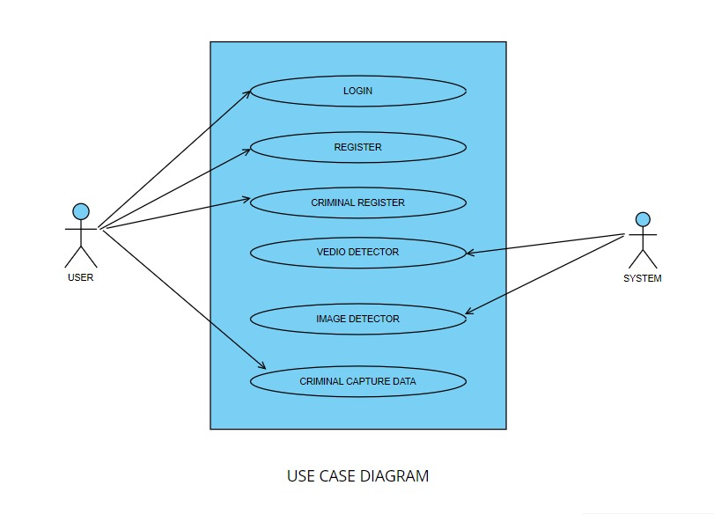

Fig.1

#### Data Base Design and Databases:

Designing a database for a fake news detection system involves organizing and structuring data to efficiently store and retrieve information related to news articles, user interactions, and system configurations. Below is a simplified outline of the database design, and the potential tables that could be included:

**Database Design:**

In this project, we use two database and 1 csv file to store and retrieve the data.

Based on the provided database schema and file formats, the criminal face detection system project involves the following data structures:

**3.2.1**. **Registration Database (registration.db):**

- Table Name: registration

- Attributes: name, father_name, mother_name, religion, gender, nationality, crime_convicted, image_path

- Description: This database stores detailed information about registered criminals, including personal details such as name, gender, and nationality, as well as specific information about past criminal activities, represented by the crime_convicted attribute. The image_path attribute stores the file path to the criminal's image for identification purposes.

**3.2.2**. **User Credentials Database (user_credentials.db):**

- Table Name: users

- Attributes: username, password

- Description: This database maintains user credentials for accessing the system. It stores usernames and corresponding hashed passwords to ensure secure authentication and access control.

**3.2.3**. **Attendance Log (attendance.csv):**

- Attributes: name, date, time

- Description: This CSV file serves as an attendance log, recording the names of individuals detected in live video streams along with timestamps indicating the date and time of detection. It provides a chronological record of criminal sightings for monitoring and analysis purposes.

These data structures collectively support the functionalities of the criminal face detection system, facilitating user authentication, registration of criminal profiles, real-time detection of suspects, and logging of criminal sightings for further investigation and analysis.

#### Sequence Diagram:

#### The sequence diagram for the criminal face detection system project outlines the sequential interactions among various components and actors involved in the system's operations. It begins with the user's attempt to access the system, initiating the authentication process. Upon providing credentials, the system verifies them against the user_credentials.db database, granting access upon successful authentication. Subsequently, a law enforcement officer may opt to register a new criminal profile by selecting the "Criminal Register" option. This action triggers a series of interactions where the officer fills in relevant details, such as the criminal's name, gender, nationality, and crime history. The system then validates and stores this information in the registration.db database. Once authenticated, the officer can utilize the "Video Detector" option to initiate real-time face detection from live video streams. The system processes frames for face detection and compares detected faces against records in the database. Upon detecting a match, the system displays relevant information about the identified criminal and logs the sighting in the attendance.csv file, capturing details such as the criminal's name, date, and time of detection. These interactions highlight the flow of control and data exchange within the criminal face detection system, enabling efficient identification and logging of criminal activity for law enforcement purposes.

#### 

#### Fig.2

#### Activity Diagram:

#### The activity diagram for the criminal face detection system project illustrates the flow of activities and decisions involved in the system's functionalities. It begins with the user's interaction with the system, where they are prompted to either log in or register. If the user chooses to log in, the system verifies their credentials against the user_credentials.db database. Upon successful authentication, the user gains access to the system's features. Alternatively,

#### if the user opts to register, they are directed to a registration form to input details about the criminal, such as name, gender, and crime history. The system validates and stores this information in the registration.db database. Following authentication or registration, the user may engage in various activities, including initiating real-time face detection from live video streams or uploading images for comparison against the criminal database. These activities are represented as decision points, leading to different paths depending on the user's choices. The activity diagram captures the sequential flow of actions within the system, providing a visual representation of the user journey and system functionality.

#### 

#### Fig.3

#### Deployment Diagram:

The deployment diagram for the criminal face detection system project depicts the physical deployment of software components and hardware resources in a distributed environment. At the core of the deployment is the application server hosting the system's software components,

including the user interface, face detection algorithms, and database management system. This server is connected to a relational database server, which hosts the registration.db and user_credentials.db databases, storing information about registered criminals and user credentials, respectively. Additionally, the system relies on external resources such as surveillance cameras for capturing live video streams and image files for comparison. These cameras are connected to the application server via a network infrastructure, facilitating real-time face detection. The deployment diagram also illustrates the interaction between the system and end-users, who access the system through various devices such as desktop computers, laptops, or mobile devices connected to the network. Overall, the deployment diagram provides a comprehensive overview of the system's architecture, highlighting the distribution of software components and hardware resources across the deployment environment. 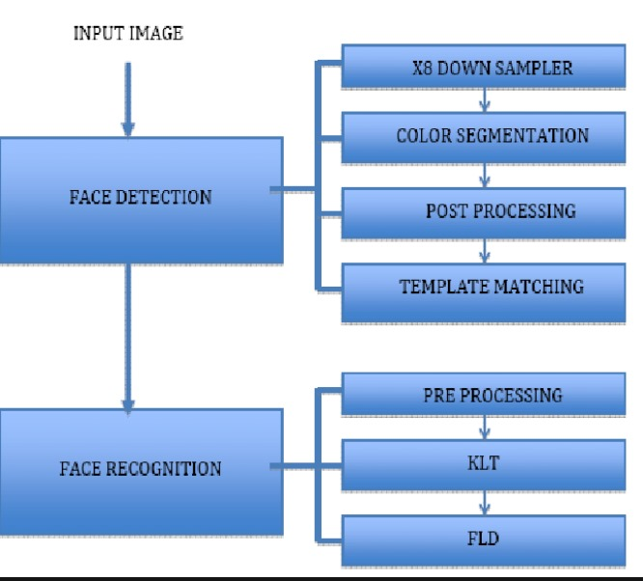

#### Fig.4

### SCREEN SHOTS

### Code Screenshots:

### 

### 

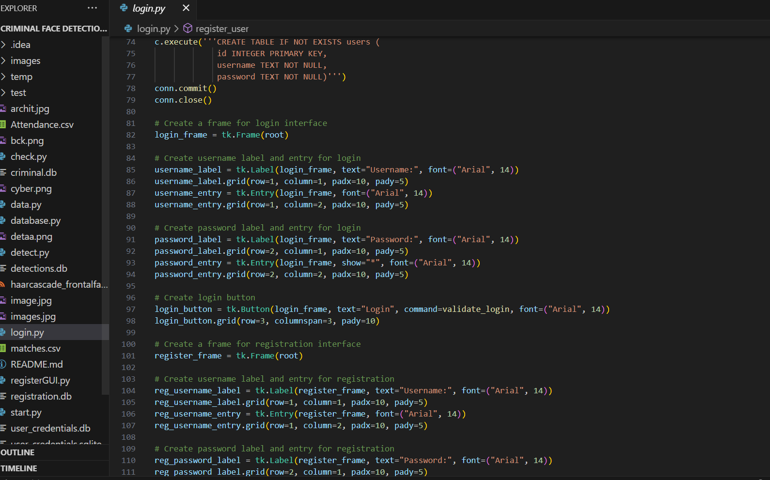

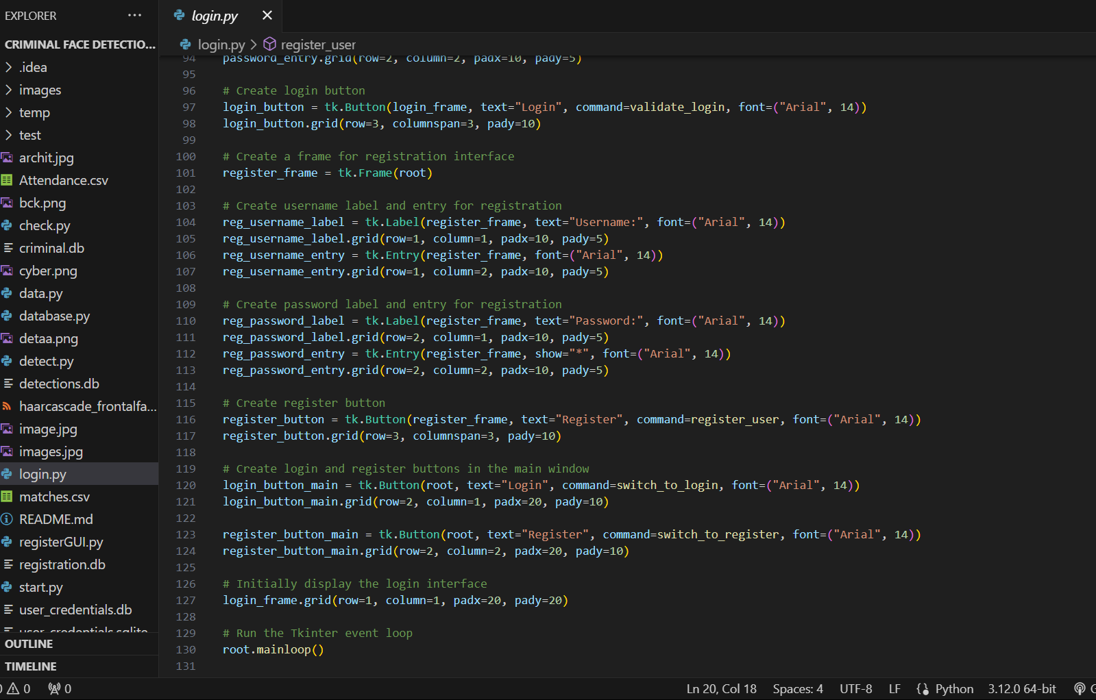

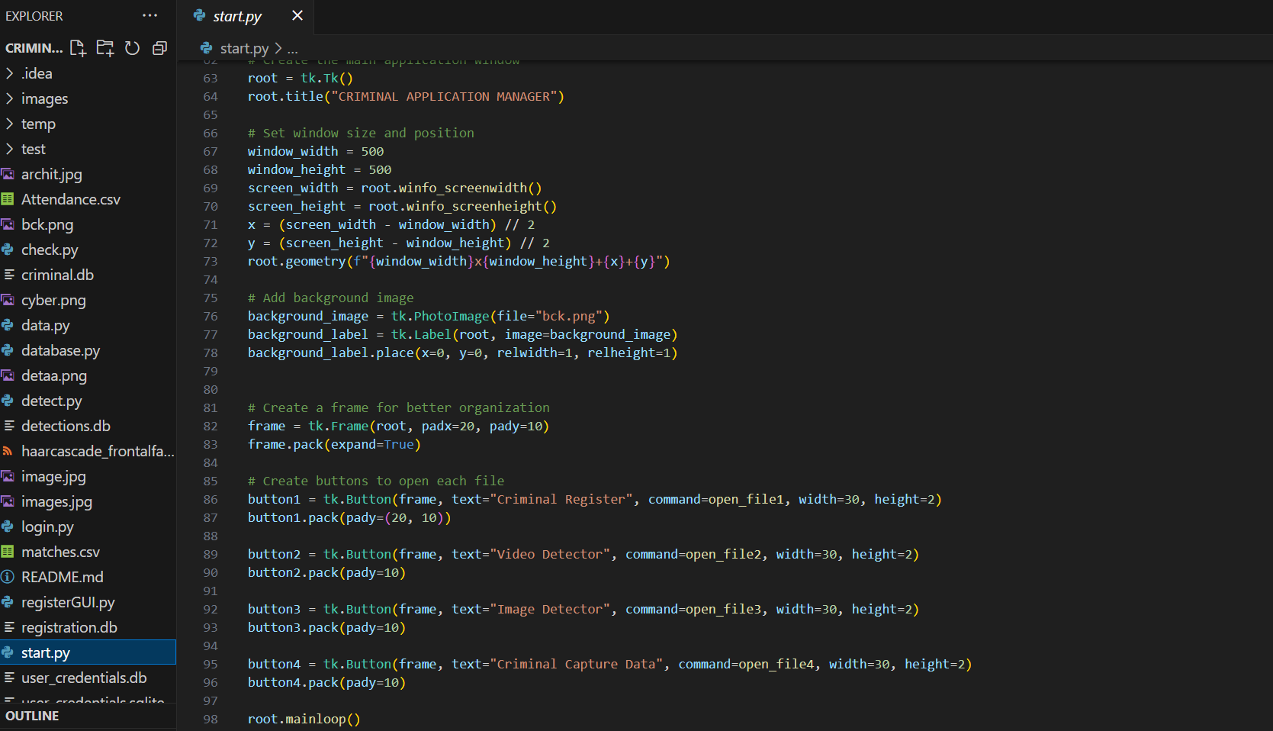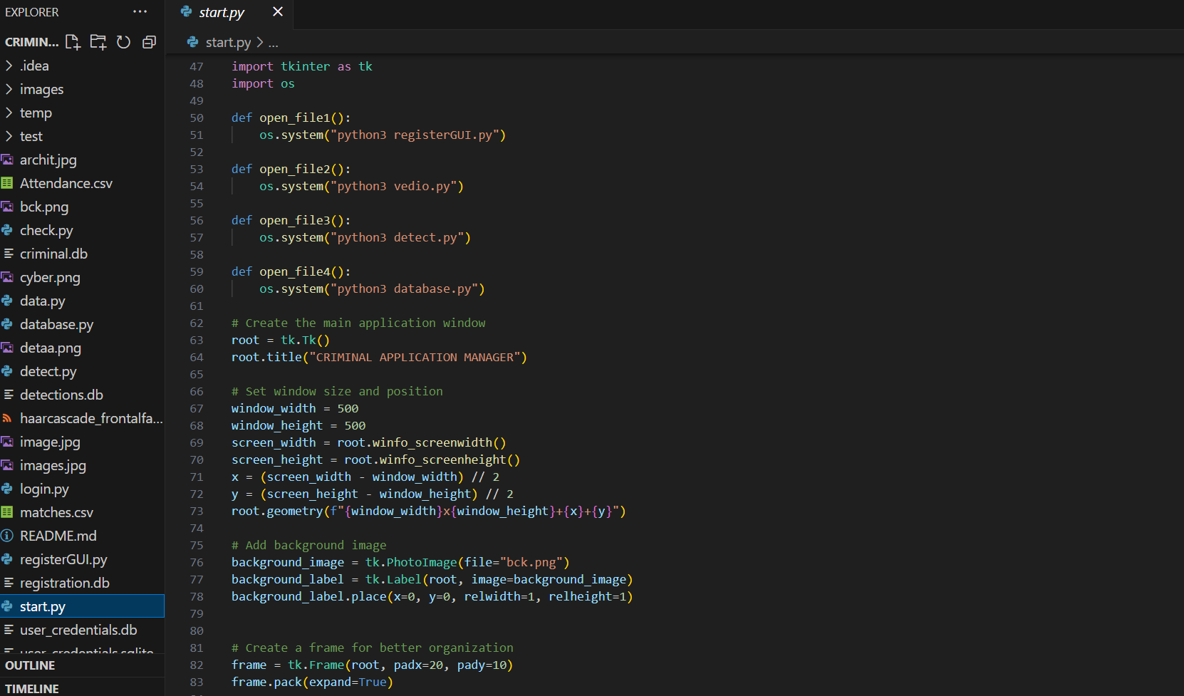

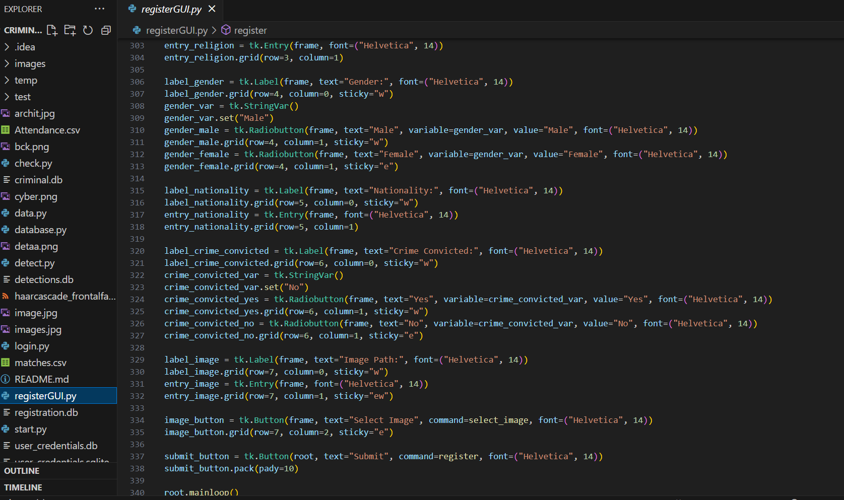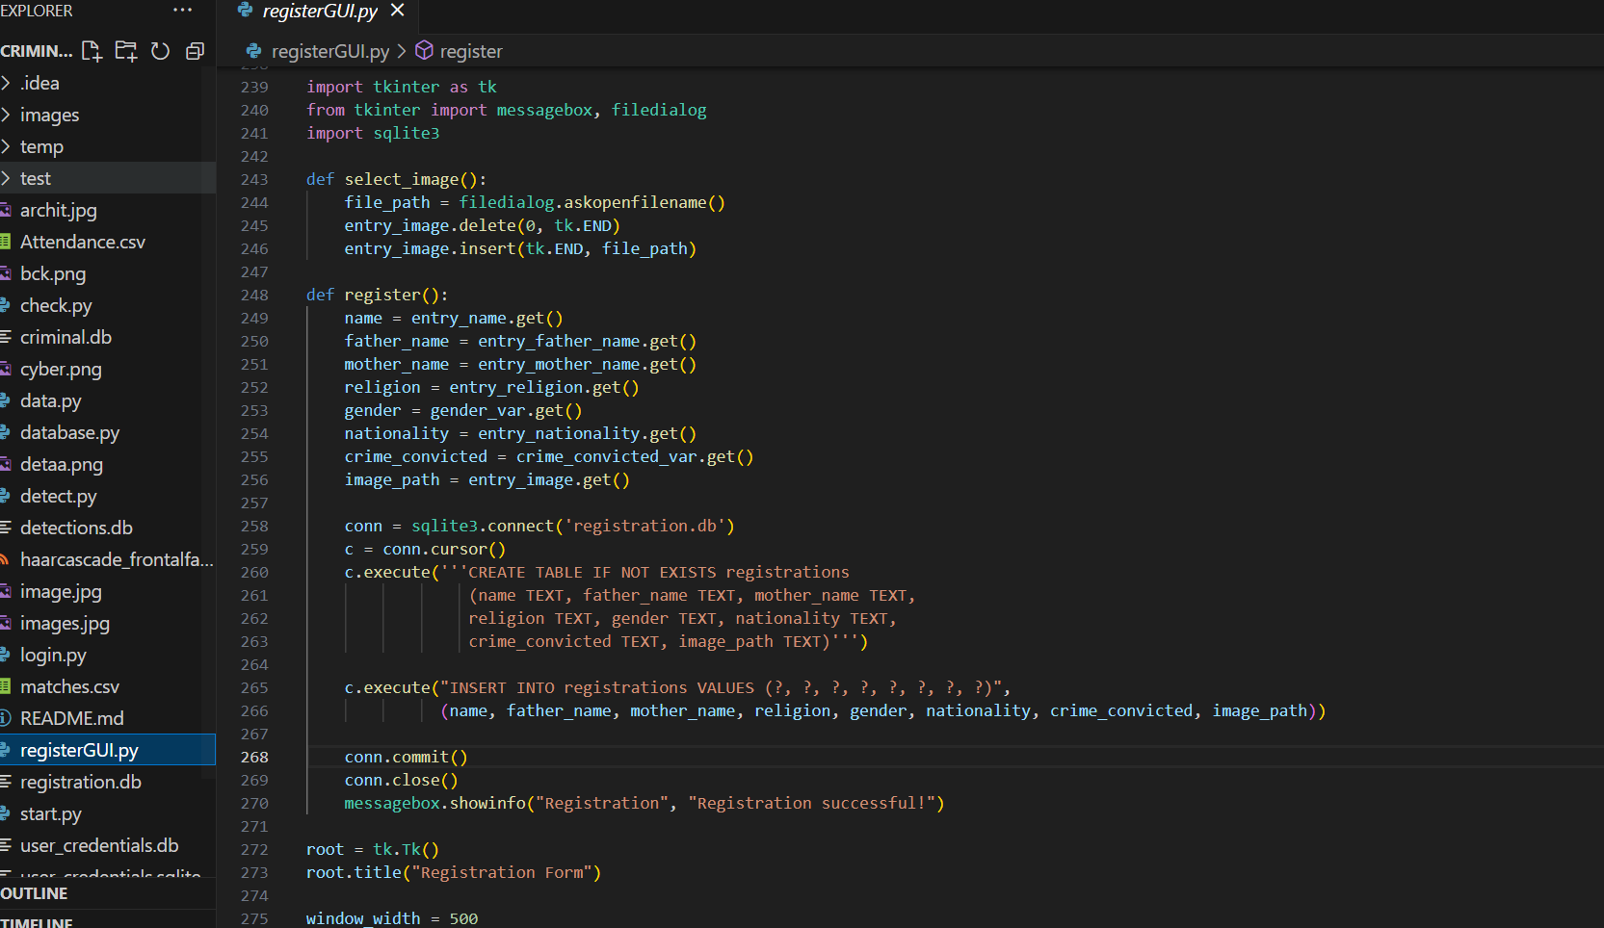

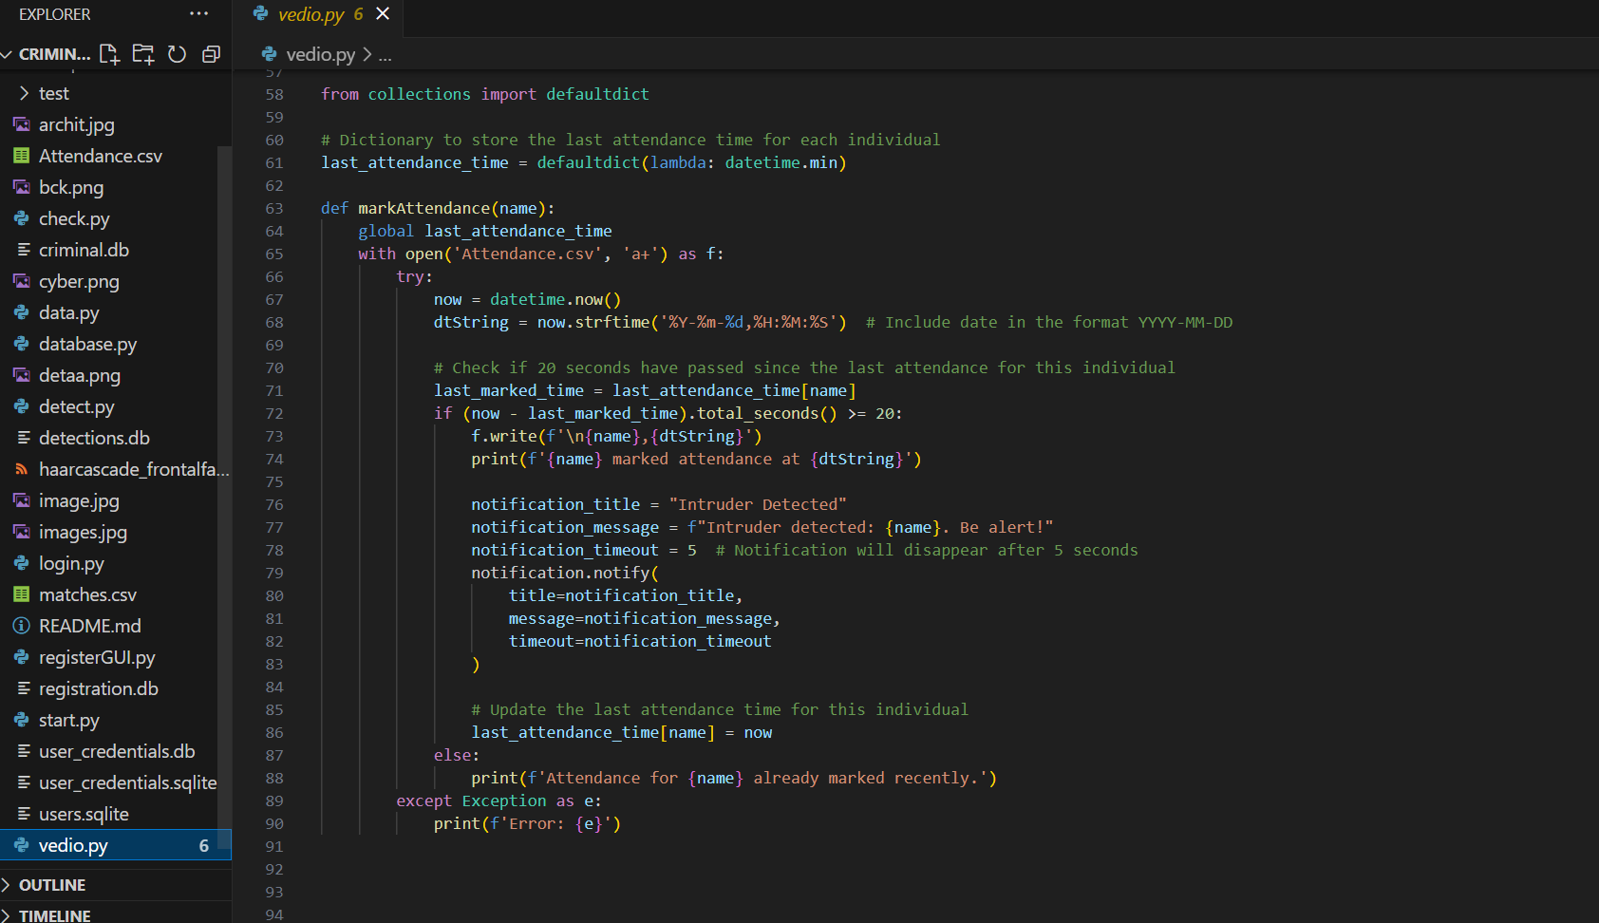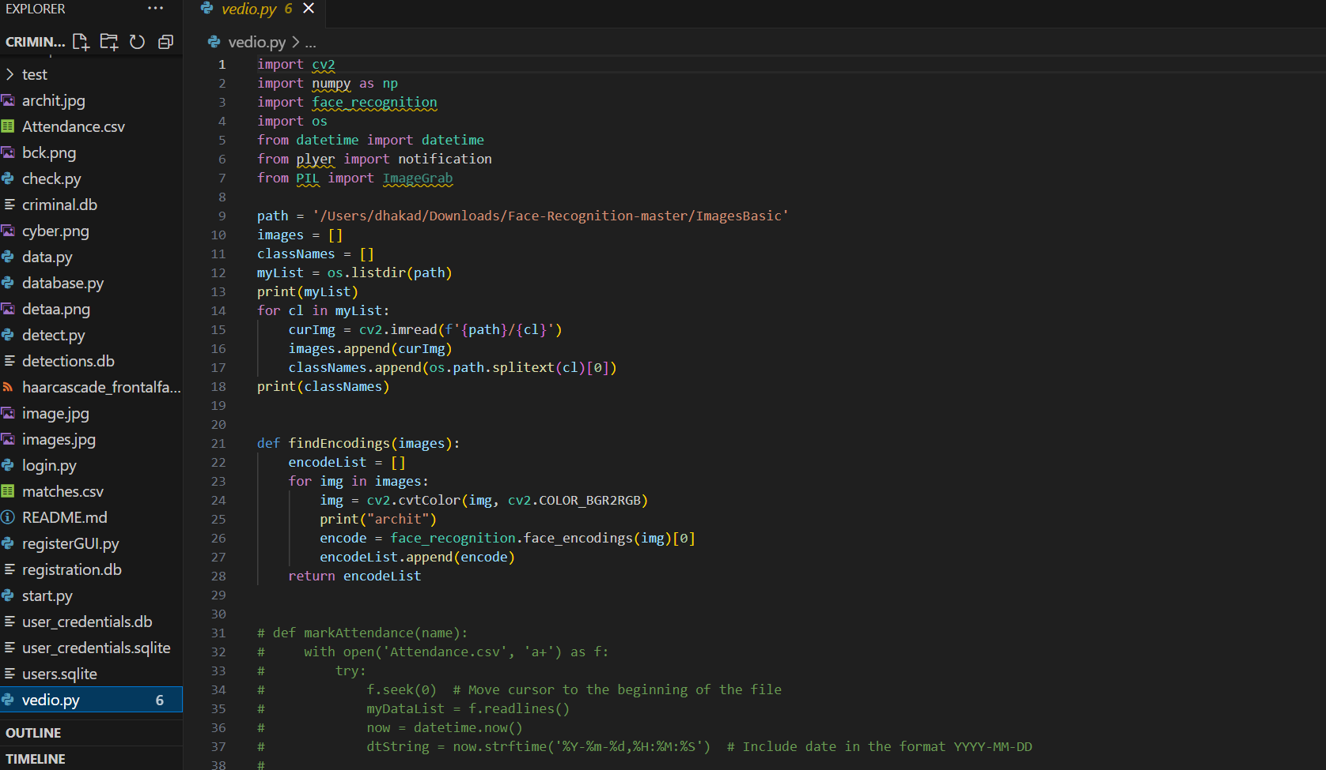

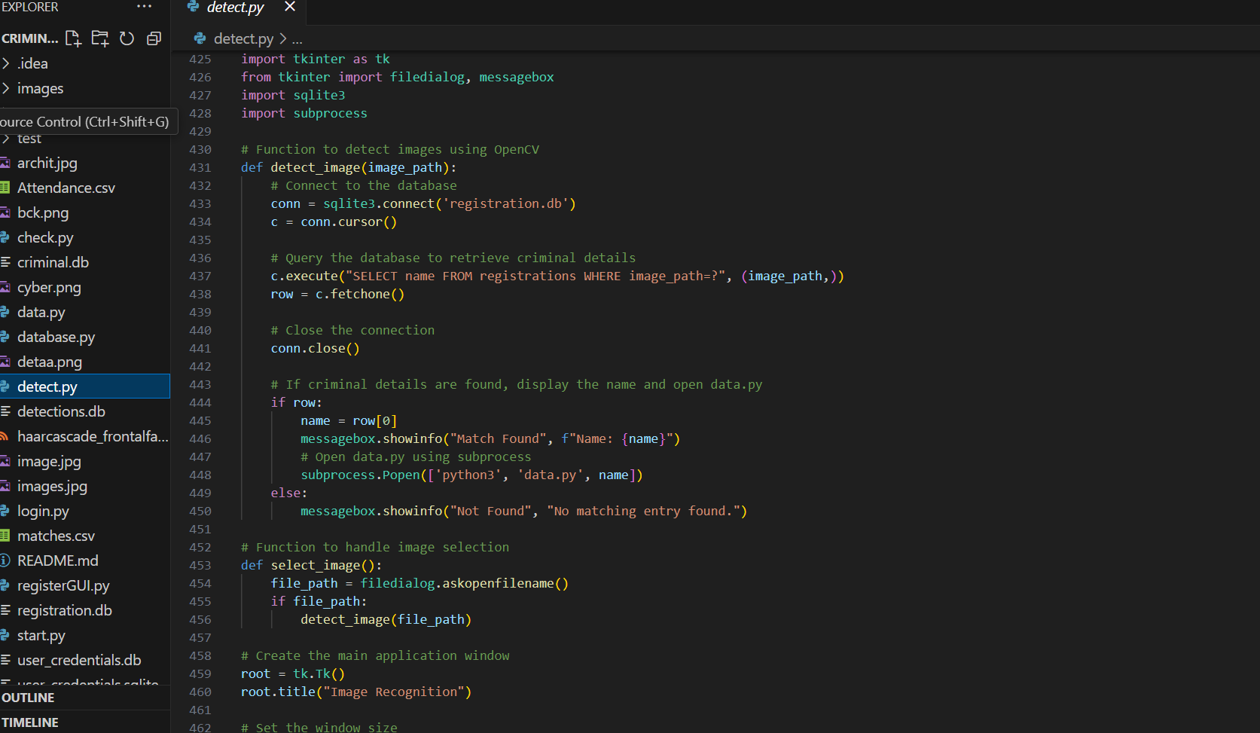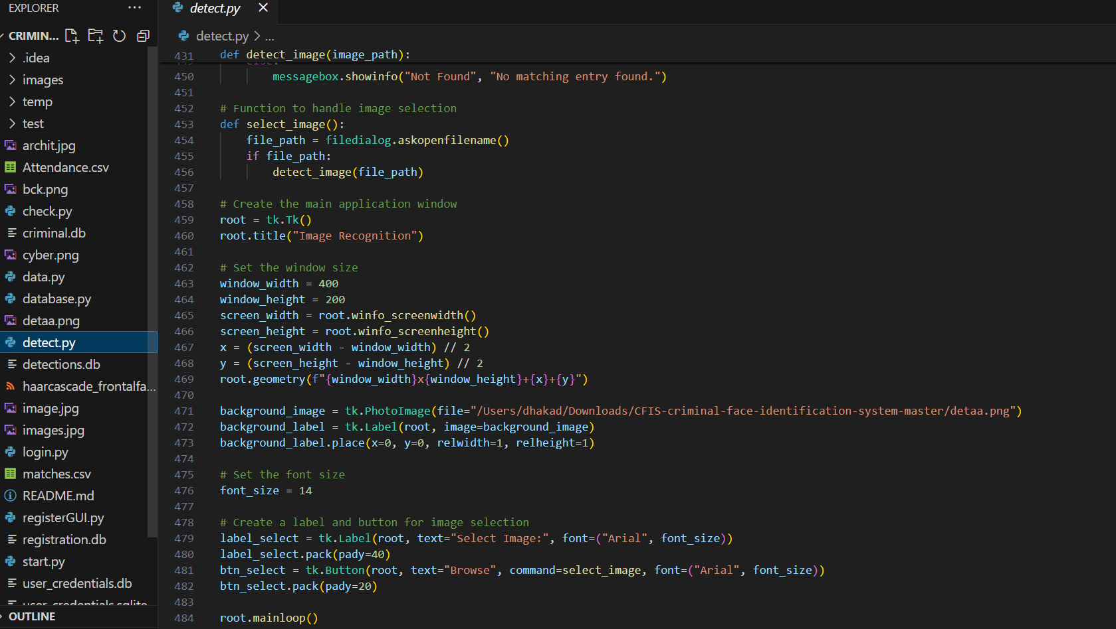

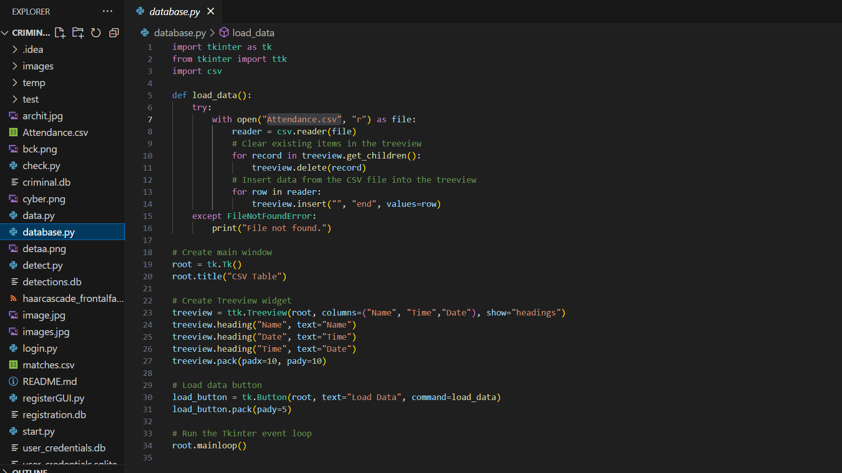

**Output Screenshots:**

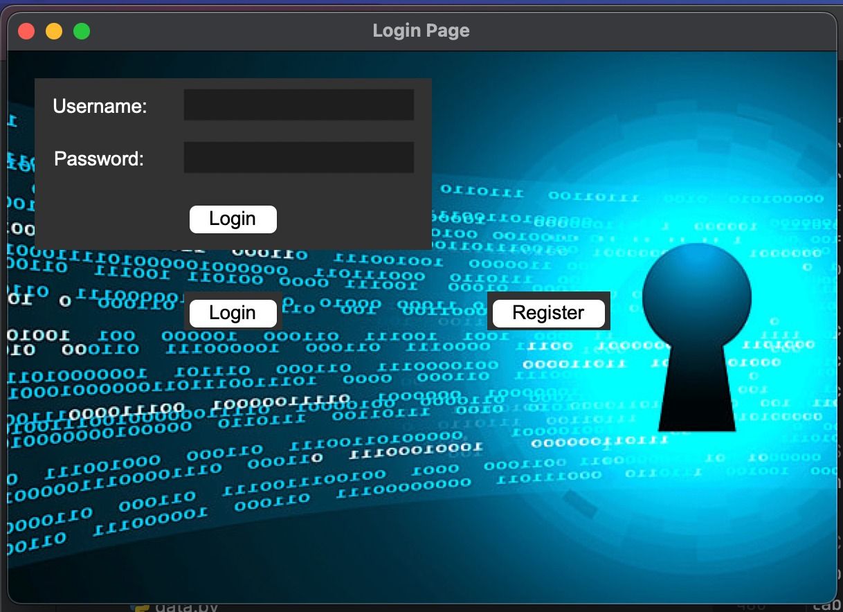

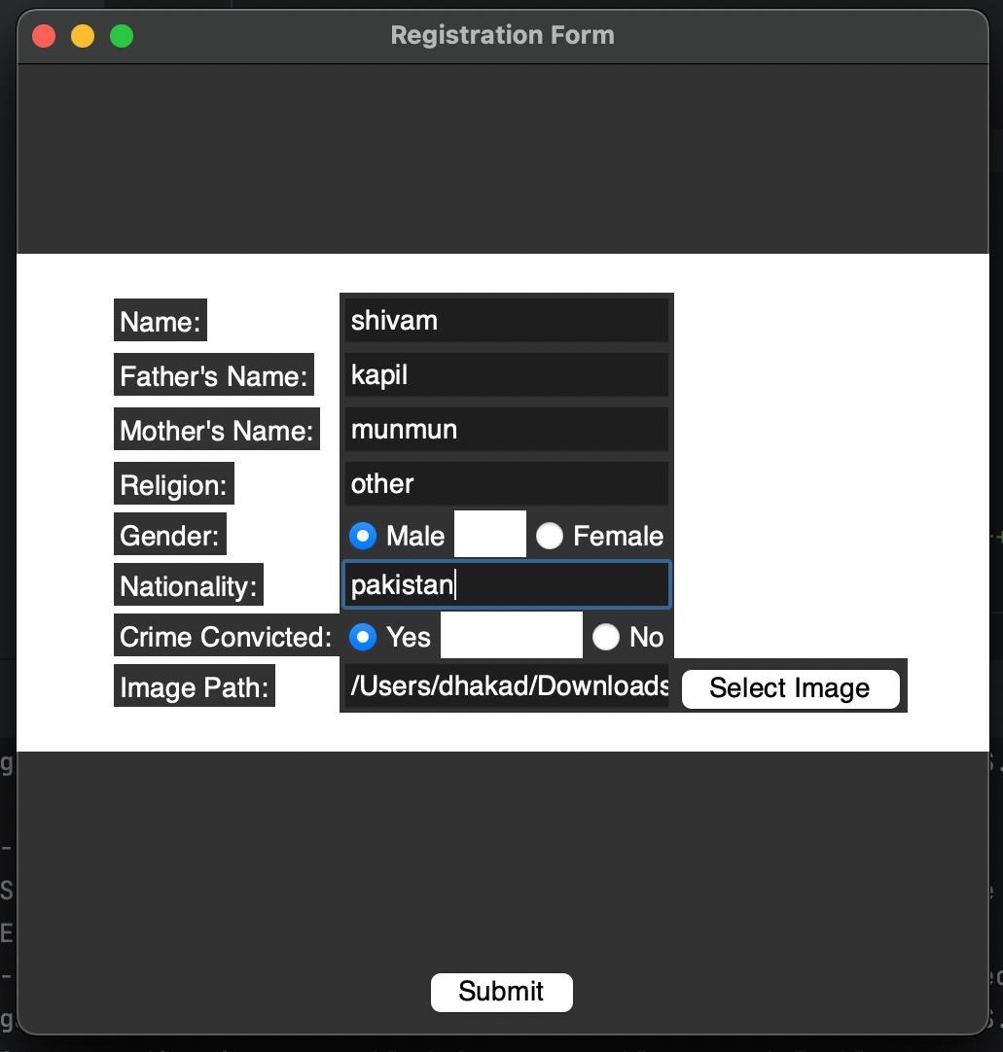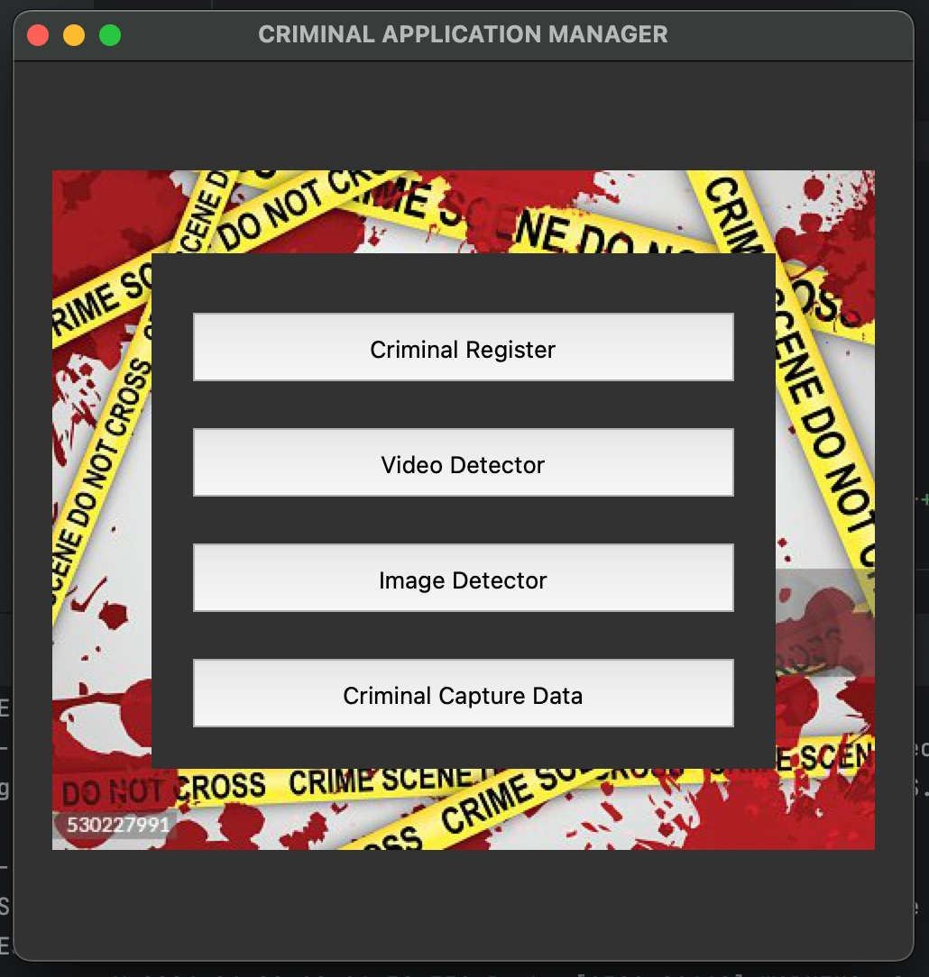

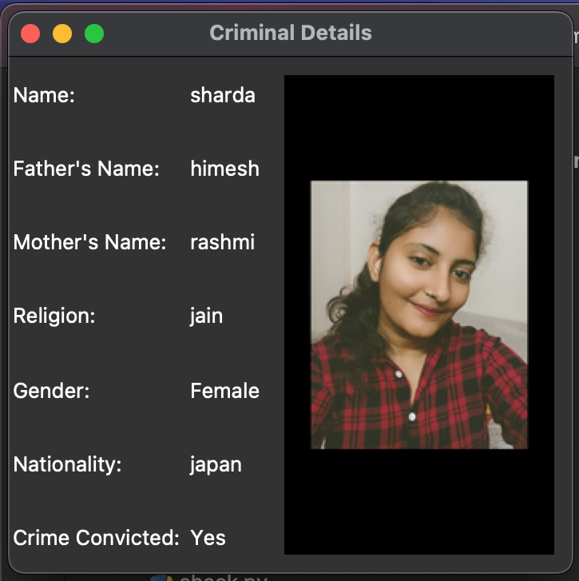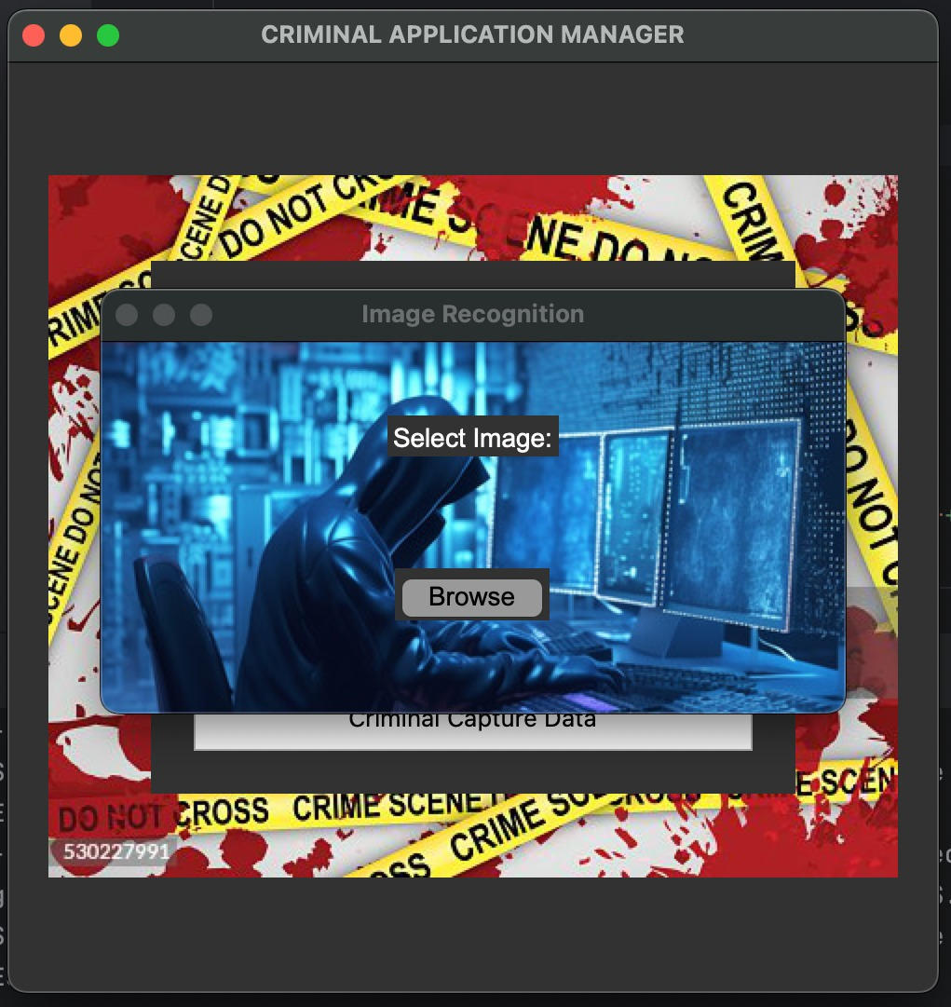

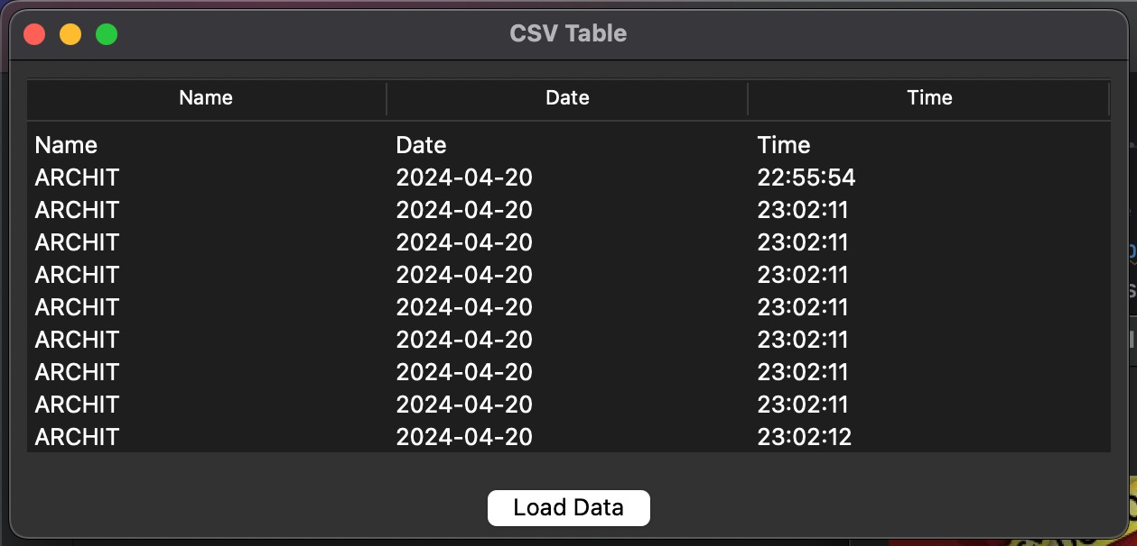

1. **TESTING**

Testing for the criminal face detection system project involves comprehensive evaluation of its functionalities, ensuring accuracy, reliability, and usability. Unit testing is conducted to verify the correctness of individual components such as user authentication, criminal registration, and face detection algorithms. Integration testing assesses the interactions between different modules and databases, confirming seamless data flow and system interoperability. Real-time face detection functionalities are rigorously tested using simulated and live video streams to validate accuracy, speed, and robustness in identifying suspects. Additionally, image comparison functionalities are tested to ensure accurate matching of uploaded images against the database of registered criminals. Usability testing is performed to evaluate the user interface's intuitiveness and responsiveness, ensuring ease of navigation and interaction for law enforcement personnel. Finally, security testing is conducted to identify and mitigate vulnerabilities such as unauthorized access, data breaches, or manipulation of sensitive information. Through thorough testing methodologies, the criminal face detection system undergoes rigorous validation to ensure its effectiveness and reliability in aiding law enforcement efforts.

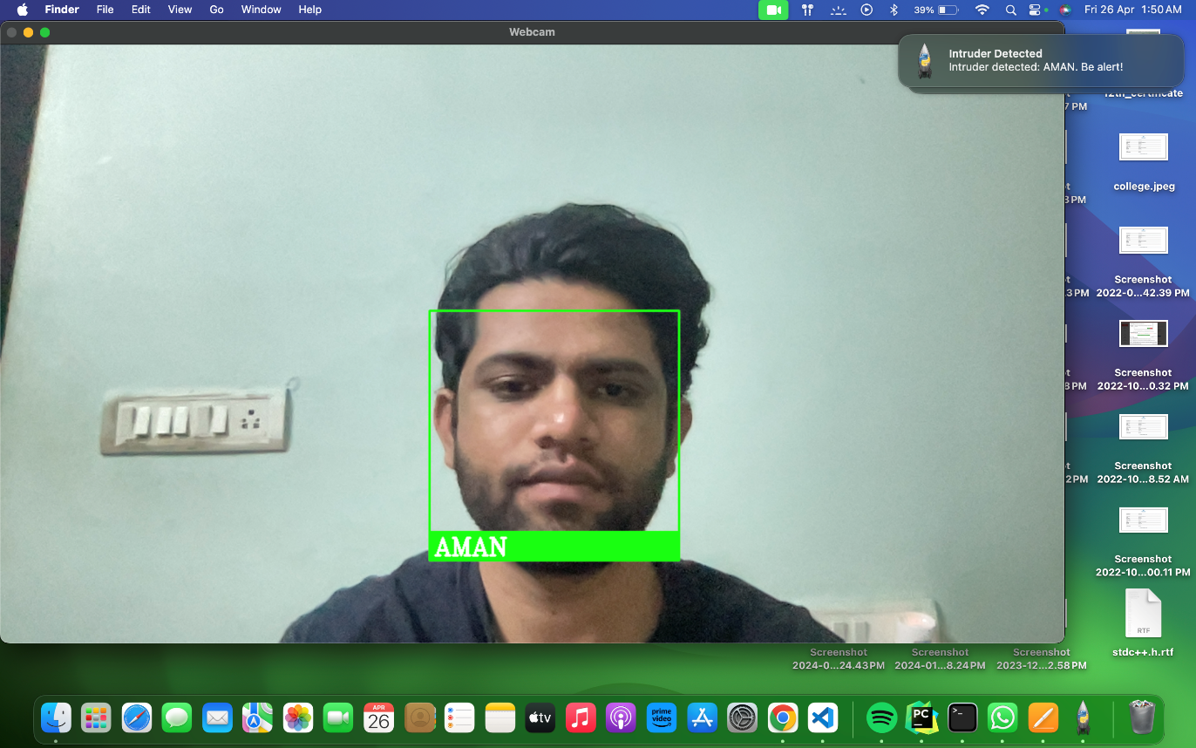

1. **LIMITATIONS OF PROJECT**

* **Accuracy**: The accuracy of face detection algorithms can be affected by factors such as lighting conditions, camera angles, and occlusions, leading to potential false positives or false negatives.
* **Data Quality**: The effectiveness of the system relies heavily on the quality and completeness of the criminal database. Inaccurate or incomplete data may result in incorrect identifications or missed matches.
* **Hardware Requirements**: Real-time face detection and processing require significant computational resources, which may pose limitations on the types of devices or infrastructure where the system can be deployed effectively.
* **Privacy Concerns**: The collection and storage of sensitive biometric data raise privacy

concerns, requiring strict adherence to regulations and protocols for data protection and consent.

1. **FUTURE SCOPE OF PROJECT**

The future scope of the criminal face detection system project is vast and holds immense potential for further development and enhancement. One avenue for expansion involves refining the accuracy and reliability of face detection algorithms through advancements in machine learning and computer vision techniques. Additionally, integrating multimodal biometric authentication methods, such as iris recognition or voice analysis, could bolster the system's identification capabilities, particularly in scenarios where facial features are obscured or altered. Furthermore, exploring real-time behavioral analysis and anomaly detection techniques could augment the system's ability to identify suspicious behavior and potential threats. Collaboration with law enforcement agencies and research institutions could facilitate the integration of cutting-edge technologies and best practices, ensuring continuous innovation and adaptation to evolving security challenges. Moreover, addressing privacy concerns, ethical considerations, and regulatory requirements will remain paramount, necessitating ongoing efforts to develop transparent and accountable governance frameworks for the responsible use of facial recognition technology in law enforcement contexts. Overall, the future scope of the project is characterized by the pursuit of heightened accuracy, expanded functionality, and ethical responsibility in leveraging facial recognition technology to enhance public safety and security.

1. **REFERENCES**

[1] IMRAN SHAFI, SADIA DIN , ZAHID HUSSAIN, IMRAN ASHRAF, GYU SANG CHOI, “Adaptable Reduced-Complexity Approach Based on State Vector Machine for Identification of Criminal Activist on Social Media,” in IEEE, pp. 2021, doi: 10.1109/ACCESS.2021.3094532.

[2] S.AYYAPPAN , Dr.S.MATILDA, “Criminals And Missing Children Identification Using Face Recognition And Web Scrapping,” in IEEE, pp. 2020.

[3] Sanika Tanmay Ratnaparkhi, Dr. Pooja Singh, Aamani Tandasi, Dr. Nidhi Sindhwani,“Comparative Analysis of Classifiers for Criminal Identification System Using Face Recognition,” in 9th International Conference on Reliability, Infocom Technologies and Optimization (Trends and Future Directions), 2021, pp. 978-1-6654-1703, doi: 10.1109/ICRITO51393.2021.9596066.

[4] <https://www.researchgate.net/publication/371765056_Criminal_Face_Detection_System>

[5] <https://ijcrt.org/papers/IJCRT2401113.pdf>

**APPENDIX A: PROJECT PROPOSAL**

The appendix for the criminal face detection system project encompasses several key components crucial for understanding, implementing, and maintaining the system.

Firstly, the database schema outlines the structure of the registration.db and user_credentials.db databases, detailing the tables, attributes, and data types used for storing information about registered criminals, user credentials, and attendance logs. The source code repository includes scripts, modules, and libraries developed for implementing various functionalities such as user authentication, criminal registration, face detection algorithms, and database interactions. User manuals provide comprehensive instructions for system installation, configuration, and usage, catering to law enforcement personnel and administrators. Testing documentation, including test plans, test cases, and results, ensures the validation of system functionalities and performance across different testing scenarios.

Additionally, privacy policies and legal compliance documentation outline the system's data handling practices and adherence to regulatory requirements related to privacy and surveillance laws. The deployment diagram illustrates the physical deployment of software components and hardware resources in a distributed environment, providing insights into the system's architecture and infrastructure requirements.

In addition to the core components outlined in the appendix, the project's future scope encompasses several avenues for expansion and innovation. One area of focus involves enhancing the accuracy and robustness of face detection algorithms through advancements in machine learning and computer vision techniques. Research in deep learning architectures and training methodologies could lead to significant improvements in the system's ability to detect and recognize faces accurately under challenging conditions such as varying lighting, angles, and occlusions. Furthermore, the integration of multimodal biometric authentication methods, such as iris recognition or voice analysis, presents an opportunity to enhance the system's identification

capabilities, particularly in scenarios where facial features may be obscured or altered.

Moreover, exploring real-time behavioral analysis and anomaly detection techniques could augment the system's ability to identify suspicious behavior and potential threats. By analyzing patterns of movement, gestures, or facial expressions in live video streams, the system could flag individuals exhibiting behavior indicative of criminal intent, enabling proactive intervention by law enforcement personnel. Collaborations with academic researchers, industry experts, and law enforcement agencies could facilitate the integration of cutting-edge technologies and best practices, ensuring the system remains at the forefront of innovation in the field of facial recognition technology for public safety and security applications.

Furthermore, addressing privacy concerns, ethical considerations, and regulatory requirements will remain paramount in the continued development and deployment of the system. Ongoing efforts to develop transparent and accountable governance frameworks for the responsible use of facial recognition technology in law enforcement contexts are essential. This includes implementing robust data protection measures, ensuring user consent and rights are respected, and establishing mechanisms for independent oversight and auditability. By prioritizing ethical principles and legal compliance, the project can build trust and confidence among stakeholders and the broader public, fostering widespread acceptance and adoption of the system.

Overall, the future scope of the project is characterized by a commitment to continuous improvement, innovation, and ethical responsibility in leveraging facial recognition technology to enhance public safety and security. By embracing emerging technologies, collaborating with stakeholders, and upholding the highest standards of privacy and ethics, the project aims to remain at the forefront of innovation in the field, contributing to the advancement of law enforcement capabilities and the protection of communities.